

Form 2
Capstone Design System Analysis
Title: Mobile Sales Canvassing Application

GROUP MEMBER:
No. | Student Name | Student ID
1. | Dannis Surya Ridfan | 001202300188
2. | Pieter Utomo Wijaya | 01202300096
3. | Muhammad Ibnul Aroby | 01202300086

Advisor: Abdul Ghofir

Submitted for
Capstone Design Project
to Faculty of Computer Science
President University

TABLE OF CONTENT

STATEMENT OF ORIGINALITY

In my capacity as an active student at President University and as the author of the Capstone Design Project stated below:
Name : 1. Dannis Surya Ridfan – 001202300188
2. Pieter Utomo Wijaya – 001202300096
3. Muhammad Ibnul Aroby – 001202300086
Faculty : Computer Science
I hereby declare that my Capstone Design Project entitled “Implementation of Smart Human Resource Management with GPS-Integrated Mobile Application Tracking” is to the best of my knowledge and belief, an original piece of work based on sound academic principles. If there is any plagiarism detected in this final project, I am willing to be personally responsible for the consequences of these acts of plagiarism and will accept the sanctions against these acts in accordance with the rules and policies of President University.
I also declare that this work, either in whole or in part, has not been submitted to another university to obtain a degree.

Cikarang, January 2024

Signer 1 | Signer 2 | Signer 3
Student Name – NIM | Student Name – NIM | Student Name – NIM

Mobile Sales Canvassing Application

Approved:

Lecturers Name  Capstone Advisor | {Head of Study Program Name}  Study Program Head of XX

Prof. Dr. Ir. Wiranto Herry Utomo, M.Kom.
Dean of Faculty of Computer Science

- EXISTING AND PROPOSED SYSTEM

- Existing Business Process

Currently, the sales canvassing process in distribution/FMCG companies is still semi-manual and not integrated into a single system.

Sales representatives receive a list of outlets in Excel format or a physical printout from their supervisor. Travel routes are determined based on personal habits or experience without a route optimization system.

When visiting outlets, sales representatives record orders using order books or simple spreadsheets. Price calculations, discounts, and promotional schemes such as "Buy X Get Y" are done manually. This often leads to calculation errors that result in billing discrepancies and customer complaints.

After the visit is complete, sales representatives submit a visit report to their supervisor in the form of photos or a manual recap. The admin then re-enters the orders into the company's ERP system. This process results in:

- Double data entry.

- Delayed invoicing.

- Risk of human error.

- Lack of real-time monitoring.

- Lack of GPS validation of visits.

- Lack of a structured offline system.

Managers only receive weekly or monthly reports, making it difficult to intervene quickly if performance declines.

- Proposed Business Process

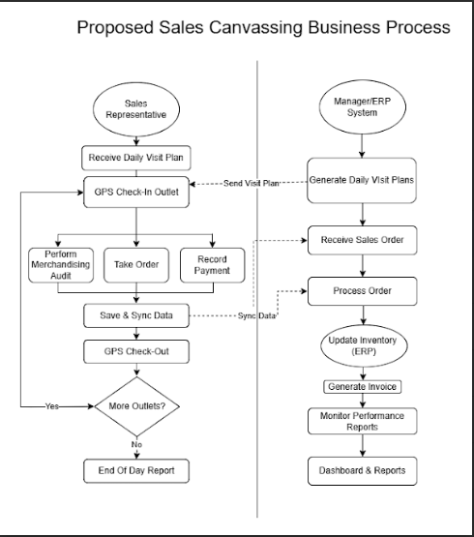

- GLOBAL DESCRIPTION OF THE PRODUCT

- Main Functionality

Mobile Sales Canvassing Application has the main functions:

- Daily Route Planning & Optimization
The system automatically generates and displays the daily visit plan for each Sales Representative.
This feature allows:
  - Route planning based on assigned outlets
  - Visit scheduling
  - Monitoring visit coverage
The objective of this functionality is to ensure structured visit planning and prevent missed outlet visits.
- GPS-Based Check-In and Check-Out
The system validates outlet visits using GPS geo-fencing technology.
Sales Representatives must perform check-in upon arrival and check-out before leaving the outlet. The system verifies location accuracy based on predefined coordinates.
This feature ensures:
- Visit authenticity
- Accountability
- Prevention of fake visits
- Outlet Profile and Stock Information
Sales Representatives can view complete outlet information, including:
- Outlet Profile
- Historical transaction data
- Outstanding payments
- Stock availability
This functionality supports better sales decision-making during customer visits.
- Sales Order Management
The system enables Sales Representative to creates sales orders directly from the mobile application. Features include:
- Product selection
- Quantity input
- Automatic price calculation
- Discount Application
- Digital signature confirmation
This functionality reduces manual errors and eliminates paper-based order forms.
- Automatic Promotion Engine
The System automatically applies promotional schemes such as:
- Buy X Get Y
- Discount percentage
- Bundle pricing
- Conditional promotions
The promotion engine ensures pricing consistency and eliminates manual miscalculation.

- Collecting and Payment Recording
Sales Representatives can record payments directly through the mobile application.
The features include:
- Payment amount input
- Payment method selection
- Receipt image upload
- Outstanding balance update
This ensures accurate financial tracking and reduces delayed reporting.
- Merchandising Audit
The system allows Sales Representatives to perform merchandising evaluation at the outlet. Includes:
- Audit checklist form
- Display compliance validation
- Shelf photo capture
The collected data can be analyzed to evaluate product visibility and brand performance.
- Offline Mode with Auto Synchronization
The application supports offline data storage using local database technology. When internet connectivity is unavailable:
- Orders stored locally
- Visit data is recorded offline
When connectivity is restored:
- Data automatically synchronizes to the central server
This ensures operational continuity in areas with unstable internet condition.
- Web-Based Monitoring Dashboard
Supervisors and Managers can access a web dashboard to monitor:
- Sales performance
- Visit coverage
- Strike Rate
- Order Volume
- Collection summary
This functionality provides real-time analytics and supports data-driven decision-making.
- ERP Integration
The systems integrate with the company’s ERP system through REST API. Confirmed orders are automatically transmitted to ERP to:
- Generate invoices
- Update stock records
- Maintain financial records
This eliminates double data entry and improves operational efficiency.

Overall, the main functionalities of the system are designed to digitalize manual sales operations, enhance field activity accountability, improve data accuracy and provide real-time business insights for management.

- User Characteristics

Table 2. 1 User Characteristic
Users | Responsibility | Access rights | Education Levels | Skill Levels | Type of Training
Sales Representative | Visit, Outlet, create order | Mobile app | High School/Diploma | Basic Smartphone | Operational training
Sales Manager | Analyze performance & Monitor Team | Mobile + Web | Diploma/Bachelor | Intermediate | Dashboard training & System Overview
System Admin | Manage sytsem data | Full Access | IT Background | Advanced | Technical training

- Constraints
The development and implementation of the Mobile Sales Canvassing Application are subject to several constraints that may influence system design and operational performance.
  - Internet Connectivity Limitation
Sales Representatives may operate in rural or semi-urban areas where internet connectivity is unstable or unavailable.
This constraint requires the system to support offline data storage and automatic synchronization once network connectivity is restored.

  - GPS Accuracy and Device Dependency
The GPS validation feature depends on the accuracy of mobile device sensors. Different device specifications may affect location precision.
Therefore, the system must define acceptable geo-fencing tolerance levels to prevent false check-in rejection.

  - Integration with Existing ERP System
The application must integrate with the company’s existing ERP system using available API endpoints.
Integration constraints may include:
- Limited API documentation
- Different data structure formats
- Authentication protocol restrictions
This requires careful mapping between systems.

  - Budget Limitation
The system must utilize open-source technologies to minimize licensing costs.
Therefore, proprietary enterprise software solutions are excluded from consideration.

  - Data Security and Privacy Regulation
The system must ensure secure data transmission and storage, especially for financial transactions and customer data.
Security constraints include:
- Encrypted communication (HTTPS)
- Role-based access control
- Authentication and authorization mechanism

- Product Development Environment
The Product Development Environment describes the hardware and software tools used during system design and implementation.
  - Hardware Environment (Development Phase)
The development team requires:
- Laptop or PC with minimum 8GB RAM
- Android smartphone for mobile testing
- Stable internet connection for repository management
Adequate hardware ensures smooth development, debugging, and system testing.

  - Software Environment (Development Phase)
The system is developed using:
- Node.js and Express.js (Backend Development)
- PostgreSQL (Database Management System)
- React Native (Mobile Application Development)
- React.js (Web Dashboard Development)
- GitHub (Version Control)
- Postman (API Testing)
- Visual Studio Code (Code Editor)

These tools are selected due to:
- Open-source availability
- Community support
- Scalability
- Compatibility with RESTful architecture

  - Development Methodology
The system follows an iterative development approach, allowing incremental feature implementation, continuous testing, and refinement based on evaluation.

- Product Operational Environment
The Product Operational Environment describes the environment where the system will be deployed and used.
  - Hardware Environment (Operational Phase)
For Sales Representative:
- Android smartphone with GPS capability
- Minimum Android version compatible with React Native
For Admin, Supervisor, and Manager:
- PC or laptop
- Web browser (Google Chrome / Microsoft Edge)
For Server:
- Cloud-based or on-premise Linux server

  - Software Environment (Operational Phase)
Mobile Application:
- Android Operating System
Web Dashboard:
- Modern web browser
Backend Server:
- Linux OS
- Node.js runtime environment
- PostgreSQL database server

  - Network Environment
The system operates under:
- 4G/5G mobile internet
- WiFi connection
- Secure HTTPS communication
Offline mode is supported to ensure uninterrupted sales operations.

  - Security Environment
Operational security mechanisms include:
- JWT-based authentication
- Role-based access control
- Encrypted API communication
- Secure password hashing
These mechanisms ensure data confidentiality and system integrity.

- REQUIREMENT ANALYSIS

- Interface
Interface between the product and the user:

  - Hardware Interface
The system interacts directly with Android mobile devices used by Sales Representatives. The mobile device must have:
- GPS sensor for location validation
- Camera for capturing merchandising photos and payment receipts
- Local storage for offline data caching
The GPS module is used for geo-fencing validation during check-in and check-out processes. The camera module supports documentation and audit verification.

  - Software Interface
The system consists of two main interfaces:
- Mobile Application Interface
Used by Sales Representatives for operational activities such as order entry, visit validation, collection recording, and merchandising audit.
- Web-Based Dashboard Interface
Used by Supervisors and Managers for monitoring, analytics, and performance evaluation.
Additionally, the system integrates with:
- ERP system via REST API
- Database management system (PostgreSQL)
All communication between client and server uses HTTPS protocol.

  - Communication Interface
The system uses RESTful API communication over secure HTTPS protocol.
When online:
- Data is transmitted in real time to the central server.
When offline:
- Data is stored locally.
- Automatic synchronization is triggered when internet connectivity is restored.
- This ensures operational continuity in low-connectivity environments.

- Functional Description
  - Use case Diagram
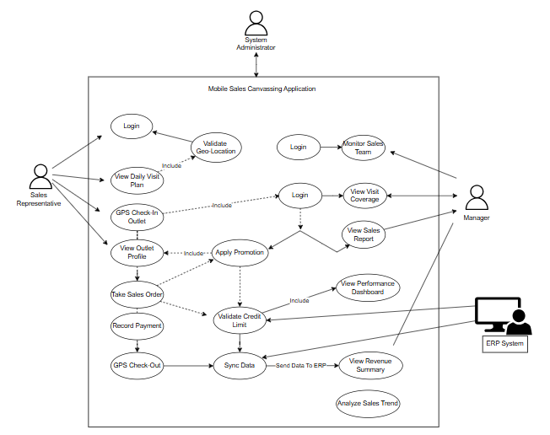

  - Use case Scenario
    - Use case: Login
Actor: Sales Representative, Manager
Pre-condition: User is registered in the system
Post-condition: User successfully logs into the system
Scenario:
- The user opens the application.
- The user enters username and password.
- The system validates the login credentials.
- The system displays the main page according to the user role.
    - Use case: View Daily Visit Plan
Actor: Sales Representative
Pre-condition: Sales Representative is logged in
Post-condition: Daily visit plan is displayed
Scenario:
- The Sales Representative selects the Daily Visit Plan menu.
- The system displays the list of outlets to be visited on that day.
- The Sales Representative selects the target outlet.

    - Use case: GPS Check-In Outlet
Actor: Sales Representative
Pre-condition: Sales Representative is logged in and GPS is active
Post-condition: Visit status is recorded
Scenario:
- The Sales Representative selects the target outlet.
- The system validates the GPS location of the Sales Representative.
- If the location matches the outlet location, the system records the check-in time and location.
- The system allows the Sales Representative to proceed with sales activities.
    - Use case: View Outlet Profile
Actor: Sales Representative
Pre-condition: Sales Representative has checked in at an outlet
Post-condition: Outlet information is displayed
Scenario:
- The Sales Representative opens the outlet profile.
- The system displays outlet information and transaction history.
    - Use case: Take Sales Order
Actor: Sales Representative
Pre-condition: Sales Representative has checked in at the outlet
Post-condition: Sales order data is saved
Scenario:
- The Sales Representative selects the products to be ordered.
- The Sales Representative enters the order quantity.
- The system sends a credit validation request to the ERP System.
- The ERP System returns the credit validation result.
- The system saves the sales order data.
    - Use case: Record Payment
Actor: Sales Representative
Pre-condition: Sales order has been created
Post-condition: Payment data is saved
Scenario:
- The Sales Representative enters payment details.
- The system saves the payment data.
- The system updates the transaction status.
    - Use case: GPS Check-Out
Actor: Sales Representative
Pre-condition: Sales activities have been completed
Post-condition: Visit status is completed
Scenario:
- The Sales Representative selects the Check-out menu.
- The system records the check-out time and location.

    - Use case: Monitor Sales Team
Actor: Manager
Pre-condition: Manager is logged in
Post-condition: Sales team activity is displayed
Scenario:
- The Manager opens the Monitor Sales Team menu.
- The system displays the activity status of Sales Representatives (check-in, transactions, and locations).
    - Use case: View Visit Coverage
Actor: Manager
Pre-condition: Manager is logged in
Post-condition: Visit coverage information is displayed
Scenario:
- The Manager selects the Visit Coverage menu.
- The system displays the list of visited and unvisited outlets.
    - Use case: View Sales Report
Actor: Manager
Pre-condition: Manager is logged in
Post-condition: Sales report is displayed
Scenario:
- The Manager selects the Sales Report menu.
- The system retrieves transaction data from the ERP System.
- The system displays the sales report.
    - Use case: View Performance Dashboard
Actor: Manager
Pre-condition: Manager is logged in
Post-condition: Performance dashboard is displayed
Scenario:
- The Manager opens the performance dashboard.
- The system displays sales performance charts.
    - Use case: View Revenue Summary
Actor: Manager
Pre-condition: Manager is logged in
Post-condition: Revenue summary is displayed
Scenario:
- The Manager selects the Revenue Summary menu.
- The system displays total sales revenue.
    - Use case: Analyze Sales Trend
Actor: Manager
Pre-condition: Sales report data is available
Post-condition: Sales trend analysis is displayed
Scenario:
- The Manager selects the Analyze Sales Trend menu.
- The system displays sales trend charts based on a selected time period.

    - Use case: Validate Credit Limit
Actor: ERP System
Pre-condition: There is a request for credit validation
Post-condition: Credit limit status is returned
Scenario:
- The system sends sales order data to the ERP System.
- The ERP System validates the customer’s credit limit.
- The ERP System sends the validation result back to the system.

    - Use case: Sync Data / Send Data to ERP
Actor: ERP System
Pre-condition: Transaction data is available
Post-condition: Data is stored in the ERP System
Scenario:
- The system sends transaction data to the ERP System.
- The ERP System stores the data in the central database.
- The ERP System returns a synchronization status.

- Data Requirement from user’s perspective
- ERD (Entity Relationship Diagram)

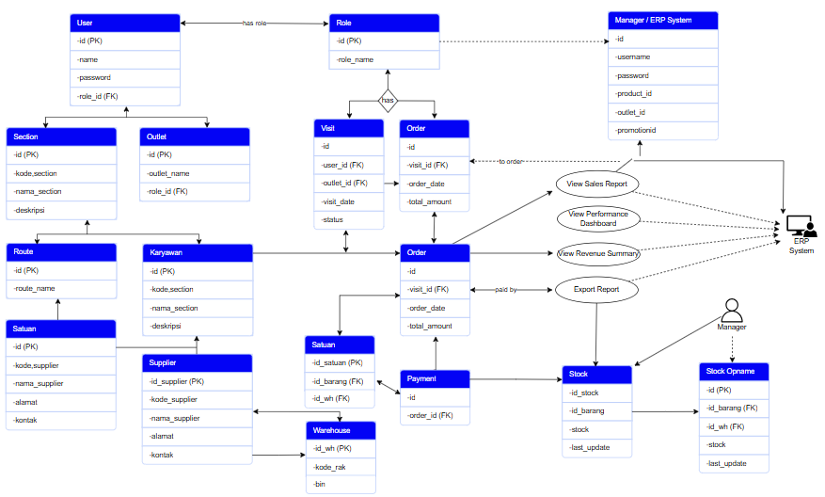

- Data Dictionary.

- Entity tables
- Relations with cardinality of each Relation

- Functional Requirement
Explain the process of the functional description that is already explained in the use-case diagram above. Use the following tools.
- Context Diagram
- Activity Diagram and Data Flow Diagram
- Describe in detail the process inside the Activity Diagram and Data flow diagram

- Non-Functional Requirement (if any)

- ALTERNATIVE SOLUTION

List the other possible solutions that can solve the problem. You can present this in points and each point has a paragraph explaining about the solution.

REFERENCES
- Pressman, R. S., & Maxim, B. R. (2019). Software Engineering: A Practitioner’s Approach (9th ed.). McGraw-Hill Education.

- Sommerville, I. (2016). Software Engineering (10th ed.). Pearson Education.

- Kendall, K. E., & Kendall, J. E. (2019). Systems Analysis and Design (10th ed.). Pearson.

- Laudon, K. C., & Laudon, J. P. (2020). Management Information Systems: Managing the Digital Firm (16th ed.). Pearson.

- Fielding, R. T. (2000). Architectural Styles and the Design of Network-Based Software Architectures (Doctoral dissertation, University of California, Irvine).

- Chen, J., & Nath, R. (2008). Business-to-business electronic commerce adoption: An empirical study. Journal of Organizational Computing and Electronic Commerce, 18(2), 111–128.

- Zhang, D., & Adipat, B. (2005). Challenges, methodologies, and issues in the usability testing of mobile applications. International Journal of Human-Computer Interaction, 18(3), 293–308.

